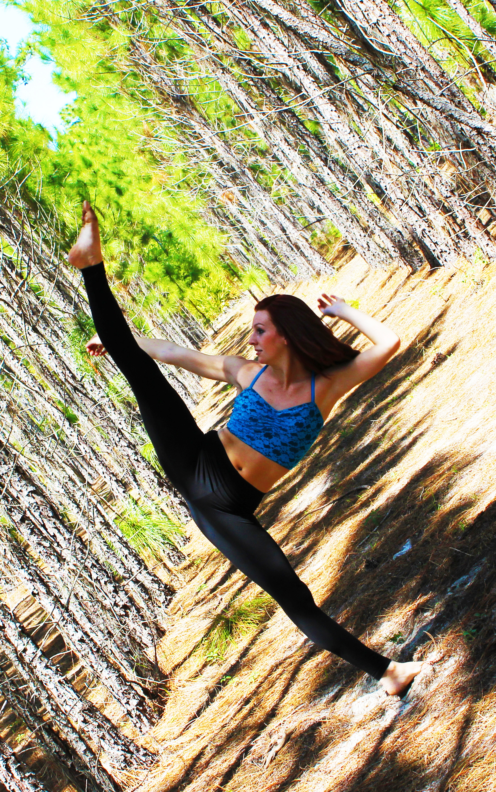 | MARISA DOLAN  904-304-0051  marisa92@aol.com  marisadolan.wix.com/marisadolan  Height: 5’6” Hair: Red  Weight: 120 lbs. Eyes: Brown
PERFORMANCE EXPERIENCE
BROADWAY/SHOWS
BROADWAY CARES GYPSY OF THE YEAR Spider-man Turn off the Dark Minskoff Theatre
UNIVERSAL ORLANDO MARILYN MONROE SHOW Diamond Bella Dancer Universal Orlando, Richard Cravens
UNIVERSAL ORLANDO SUPERSTAR PARADE Minion Recruit Dancer Universal Orlando, Colleen Defeo
UNIVERSAL ORLANDO MACYS HOLIDAY PARADE High-Kick Dancer Universal Orlando, Lora Wallace
HARD ROCK LIVE MUSICAL BRUNCH Back Up Dancer Rusty Bowen, director

TELEVISION/FILM
NEON TREES MUSIC VIDEO Back Up Dancer Scott Brendengerd, manager
GOOD MORNING AMERICA Flash Mob Dancer Chio, choreographer
KENDRA BLACK MUSIC VIDEO Back Up Dancer Mickey Sakai, choreographer

STAGE/CONCERT
MICHAEL CHAPMAN & MARY MURPHY’S Dancer Pamela Bolling, Hardrive Prod.
MILLENIUM DANCESPORT CHAMPIONSHIP
BROADWAY DANCE CENTER SHOWCASE Professional Student Bonnie Erickson, director
KAT WILDISH SHOWCASE JT Lotus Company The Ailey Citigroup Theatre
JT LOTUS DANCE COMPANY Solo/Duo/Ensemble Jessie Tomanek, director
COPPELIA VARIATION Corps de Ballet Rhonda Stampalia, director
JACKSONVILLE UNIVERSITY Dancer Brian Palmer, director
CURACAO DANCE SHOW Ensemble Teatro Luna Blou
A RHYTHM NATION DANCE COMPANY Dancer Kavin Grant. Choreo/dir.

TRAINING
BROADWAY DANCE CENTER – Professional Semester Student
STEPS ON BROADWAY
GELSEY KIRKLAND ACADEMY OF CLASSICAL BALLET
JACKSONVILLE UNIVERSITY – Dance Major- Dance & Academic Scholarship Recipient
BRAVO SCHOOL OF DANCE

- STYLES: Ballet, Pointe, Contemporary, Modern, Lyrical, Jazz, Hip-Hop, Tap, Choreography
SPECIAL SKILLS
Photography, Graphic design, Acting, Partnering, Basic acrobatic skills, Basic lyra skills, Dance instruction, Choreography and Adjudicator, United States Passport and Driver’s License

